Project Progress Report Outline

Cross Zeigler, Suchada Hapikul, Ewin Hong, Neethu Battula, Sagar Deepakgiri Goswami

Note: This is a skeletal form for the progress report meant to outline ideas for the document, **not the fully fleshed out progress report itself**

* Data Cleaning
  + Filtering Speeds [0 < SPEED < 68] (Filtering data to 2 standard deviations)
  + Filtering LINK_ID's [ count > 45000 ] (Removing LINK_IDs with fewer records)
* Data Wrangling
  + Creating the schema
  + Loading the data into the schema
  + Mutating hour, minute, weekday, day, month, year, dayofyear information from the DATA_AS_OF column.
  + Sampling the dataset for development, training, and testing.
  + Create a new dataframe for predictions in future
* Data Exploration
  + Linear Regression Insights file
* Data Analysis
  + Linear Regression
    - Models
      * years
      * month-years
    - Predictions
      * Future years
      * Future month-years
  + K-means
  + Time-Series
    - Preparation (expecting to present the preparation)
    - Model (can't make promises)
    - Prediction (not possible)
  + Decision Tree
  + MARS - Multivariate Adaptive Regression Splines
    - Model
    - Predictions
  + Created mongo collection of linkpoints and geospatial index in mongodb. added that in document
  + **Cover**
    - The Project Title
    - Author’s Names and Team #
    - Course Project Advisor/Professor’s Name(s)
    - Course Name, Number, and Section #
    - University Name
    - Date
  + **Implement proposed solutions and present preliminary results with analysis**
  + **Describe the overall progress**
    - Utilize sketches/diagrams, correction notice(s), delays and causes, change recommendations, etc. to describe the overall progress.

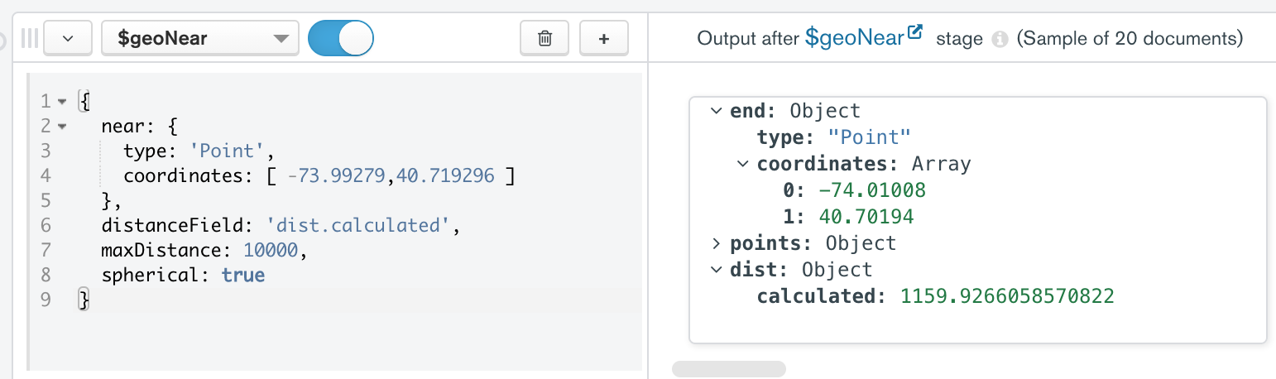

* + **Update the status of the project tasks and timeline**
    - *Mark the completed tasks and update related information*